O’ZBEKISTON RESPUBLIKASI MUDOFAA VAZIRLIGI HARBIY XAXFSIZLIK VA MUDOFAA UNIVERSITETINING AXBOROT-KOMMUNIKATSIYA TEXNOLOGIYALARI VA HARBIY ALOQA INSITUTI



AXBOROT-KOMMUNIKATSIYA TEXNOLOGIYALARI VA SUN’IY INTELLEKT KAFEDRASI
“Suniy intellekt asoslari” FANIDAN

MUSTAQIL ISH

Bajardi: Bo’ronov D.
Qabul qildi: Isakov M.

Toshkent 2025

2. Chat server dasturi (shifrlangan yozishmalar bilan)
Maqsadi:
Bir nechta chat klientlardan ulanish qabul qiladigan va ularning xabarlarini faqat shifrlangan ko‘rinishda ko‘rsatadigan server dasturi.
Asosiy funksiyalar:
- Serverni ishga tushirish/to‘xtatish:
  - IP/port sozlash.
  - “Start server”, “Stop server” tugmalari.
- Klientlar boshqaruvi:
  - Ulangan klientlar ro‘yxati: nickname, IP, ulanish vaqti.
  - Klientni majburan uzib qo‘yish (“Disconnect selected client”).
- Xabarlar oqimini ko‘rish:
  - Kelgan xabarlar faqat shifrlangan satr holida ko‘rinadi.
  - Qaysi klientdan kelgani, vaqtini ko‘rsatish.
- Log:
  - Ulanish/uzilish hodisalari logi.
  - Xohishga ko‘ra log faylga yozilishi (shifrlangan holda).
- Server tarafda deshifrlash bo‘lmaydi – bu texnik topshiriqning majburiy bandi.
UI talablar:
- Asosiy oynada 3 ta asosiy bo‘lim:
  - Server boshqaruvi paneli:
    - IP/Port ko‘rsatish va sozlash.
    - “Start”, “Stop” tugmalari.
    - Joriy holat: Running / Stopped.
  - Klientlar ro‘yxati (QTableWidget yoki QListWidget):
    - Ustunlar: Nickname, IP, Port, Connected at.
  - Xabarlar logi (QTextBrowser):
    - Format: [Vaqt] [Nick/IP]: <ShIFRLANGAN_MATN>.
- Menyu:
  - File → “Logni faylga saqlash”.
  - View → “Faqat yangi xabarlarni ko‘rsatish”, “Klientlar soni”.
Texnik talablar:
- Ko‘p klientli TCP server (threading yoki asyncio).
- Har bir yangi ulanish uchun alohida oqim yoki task.
- Kelgan xabarni o‘zgartirmasdan logga yozish va boshqa klientlarga translyatsiya qilish (xohishga ko‘ra).

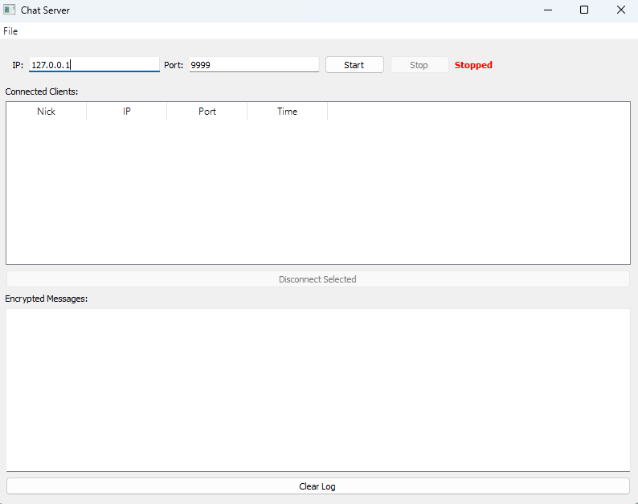
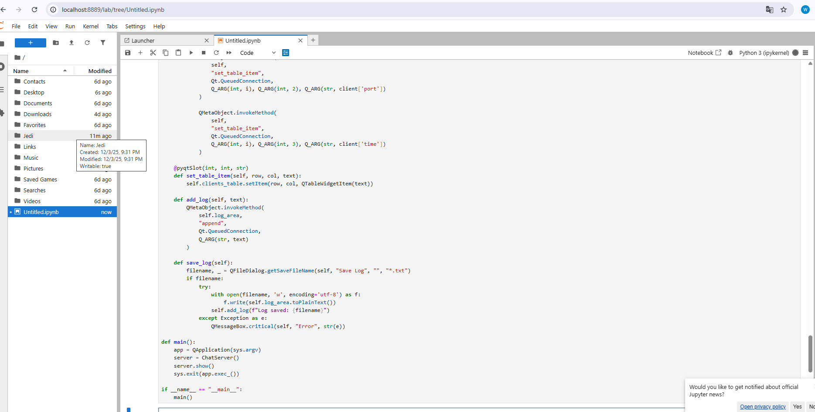

# -*- coding: utf-8 -*-
"""
Chat Server - Spyder uchun minimal versiya
"""

import sys
import socket
import threading
import time
from datetime import datetime
from PyQt5.QtWidgets import *
from PyQt5.QtCore import *
from PyQt5.QtGui import *
import base64

class ChatServer(QWidget):
def __init__(self):
super().__init__()
self.server = None
self.running = False
self.clients = []
self.lock = threading.Lock()

self.setup_ui()

def setup_ui(self):
self.setWindowTitle('Chat Server')
self.setGeometry(100, 100, 800, 600)

layout = QVBoxLayout()

# 1. Server Control
control_frame = QFrame()
control_layout = QHBoxLayout()

control_layout.addWidget(QLabel("IP:"))
self.ip_input = QLineEdit("127.0.0.1")
control_layout.addWidget(self.ip_input)

control_layout.addWidget(QLabel("Port:"))
self.port_input = QLineEdit("9999")
control_layout.addWidget(self.port_input)

self.start_btn = QPushButton("Start")
self.start_btn.clicked.connect(self.start_server)
control_layout.addWidget(self.start_btn)

self.stop_btn = QPushButton("Stop")
self.stop_btn.clicked.connect(self.stop_server)
self.stop_btn.setEnabled(False)
control_layout.addWidget(self.stop_btn)

self.status_label = QLabel("Stopped")
self.status_label.setStyleSheet("color: red; font-weight: bold;")
control_layout.addWidget(self.status_label)

control_layout.addStretch()
control_frame.setLayout(control_layout)
layout.addWidget(control_frame)

# 2. Clients List
layout.addWidget(QLabel("Connected Clients:"))
self.clients_table = QTableWidget(0, 4)
self.clients_table.setHorizontalHeaderLabels(["Nick", "IP", "Port", "Time"])
layout.addWidget(self.clients_table)

self.dc_btn = QPushButton("Disconnect Selected")
self.dc_btn.clicked.connect(self.disconnect_client)
self.dc_btn.setEnabled(False)
layout.addWidget(self.dc_btn)

# 3. Messages Log
layout.addWidget(QLabel("Encrypted Messages:"))
self.log_area = QTextEdit()
self.log_area.setReadOnly(True)
layout.addWidget(self.log_area)

# Clear button
clear_btn = QPushButton("Clear Log")
clear_btn.clicked.connect(lambda: self.log_area.clear())
layout.addWidget(clear_btn)

self.setLayout(layout)

# Menu
menubar = QMenuBar()
file_menu = menubar.addMenu("File")

save_action = QAction("Save Log", self)
save_action.triggered.connect(self.save_log)
file_menu.addAction(save_action)

exit_action = QAction("Exit", self)
exit_action.triggered.connect(self.close)
file_menu.addAction(exit_action)

layout.setMenuBar(menubar)

# Table selection
self.clients_table.itemSelectionChanged.connect(
lambda: self.dc_btn.setEnabled(self.clients_table.currentRow() >= 0)
)

def start_server(self):
ip = self.ip_input.text()
try:
port = int(self.port_input.text())
except:
QMessageBox.warning(self, "Error", "Invalid port")
return

try:
self.server = socket.socket()
self.server.bind((ip, port))
self.server.listen(5)
self.running = True

self.status_label.setText("Running")
self.status_label.setStyleSheet("color: green; font-weight: bold;")
self.start_btn.setEnabled(False)
self.stop_btn.setEnabled(True)

self.add_log(f"Server started: {ip}:{port}")

# Accept thread
threading.Thread(target=self.accept_clients, daemon=True).start()

except Exception as e:
QMessageBox.critical(self, "Error", str(e))

def stop_server(self):
self.running = False

with self.lock:
for client in self.clients:
try:
client['socket'].close()
except:
pass
self.clients.clear()
self.update_table()

if self.server:
try:
self.server.close()
except:
pass

self.status_label.setText("Stopped")
self.status_label.setStyleSheet("color: red; font-weight: bold;")
self.start_btn.setEnabled(True)
self.stop_btn.setEnabled(False)

self.add_log("Server stopped")

def accept_clients(self):
while self.running:
try:
client_socket, addr = self.server.accept()

# Get nickname
nickname = client_socket.recv(1024).decode('utf-8', errors='ignore').strip()
if not nickname:
nickname = f"Client_{addr[1]}"

client_info = {
'socket': client_socket,
'nickname': nickname,
'ip': addr[0],
'port': addr[1],
'time': datetime.now().strftime("%H:%M:%S")
}

with self.lock:
self.clients.append(client_info)
self.update_table()

self.add_log(f"{nickname} connected")

# Handle client
threading.Thread(
target=self.handle_client,
args=(client_info,),
daemon=True
).start()

except:
break

def handle_client(self, client_info):
sock = client_info['socket']

while self.running:
try:
data = sock.recv(4096)
if not data:
break

# Encode message
encoded = base64.b64encode(data).decode('utf-8')

# Log it
timestamp = datetime.now().strftime("%H:%M:%S")
log_msg = f"[{timestamp}] [{client_info['nickname']}/{client_info['ip']}]: {encoded}"

self.add_log(log_msg)

# Broadcast (optional)
self.broadcast(data, sock)

except:
break

# Disconnect
self.client_dc(client_info)

def broadcast(self, data, sender):
with self.lock:
for client in self.clients:
if client['socket'] != sender:
try:
client['socket'].send(data)
except:
pass

def client_dc(self, client_info):
with self.lock:
if client_info in self.clients:
self.clients.remove(client_info)
self.update_table()

try:
client_info['socket'].close()
except:
pass

self.add_log(f"{client_info['nickname']} disconnected")

def disconnect_client(self):
row = self.clients_table.currentRow()
if 0 <= row < len(self.clients):
with self.lock:
if row < len(self.clients):
client = self.clients[row]
self.client_dc(client)

def update_table(self):
QMetaObject.invokeMethod(
self.clients_table,
"setRowCount",
Qt.QueuedConnection,
Q_ARG(int, len(self.clients))
)

for i, client in enumerate(self.clients):
def set_item(row, col, text):
item = QTableWidgetItem(str(text))
self.clients_table.setItem(row, col, item)

QMetaObject.invokeMethod(
self,
"set_table_item",
Qt.QueuedConnection,
Q_ARG(int, i), Q_ARG(int, 0), Q_ARG(str, client['nickname'])
)

QMetaObject.invokeMethod(
self,
"set_table_item",
Qt.QueuedConnection,
Q_ARG(int, i), Q_ARG(int, 1), Q_ARG(str, client['ip'])
)

QMetaObject.invokeMethod(
self,
"set_table_item",
Qt.QueuedConnection,
Q_ARG(int, i), Q_ARG(int, 2), Q_ARG(str, client['port'])
)

QMetaObject.invokeMethod(
self,
"set_table_item",
Qt.QueuedConnection,
Q_ARG(int, i), Q_ARG(int, 3), Q_ARG(str, client['time'])
)

@pyqtSlot(int, int, str)
def set_table_item(self, row, col, text):
self.clients_table.setItem(row, col, QTableWidgetItem(text))

def add_log(self, text):
QMetaObject.invokeMethod(
self.log_area,
"append",
Qt.QueuedConnection,
Q_ARG(str, text)
)

def save_log(self):
filename, _ = QFileDialog.getSaveFileName(self, "Save Log", "", "*.txt")
if filename:
try:
with open(filename, 'w', encoding='utf-8') as f:
f.write(self.log_area.toPlainText())
self.add_log(f"Log saved: {filename}")
except Exception as e:
QMessageBox.critical(self, "Error", str(e))

def main():
app = QApplication(sys.argv)
server = ChatServer()
server.show()
sys.exit(app.exec_())

if __name__ == "__main__":
main()
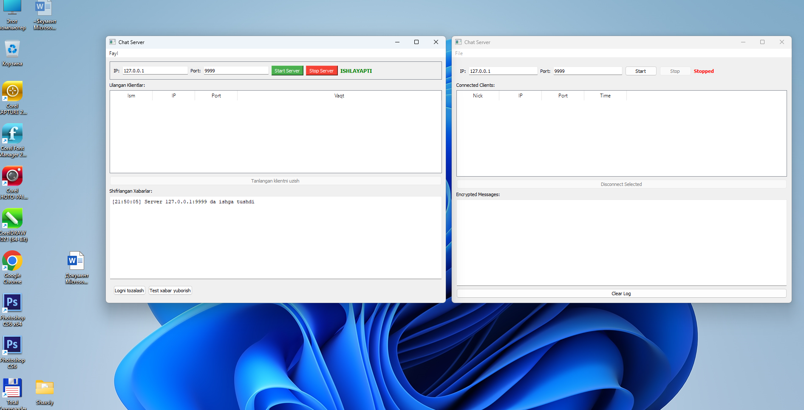

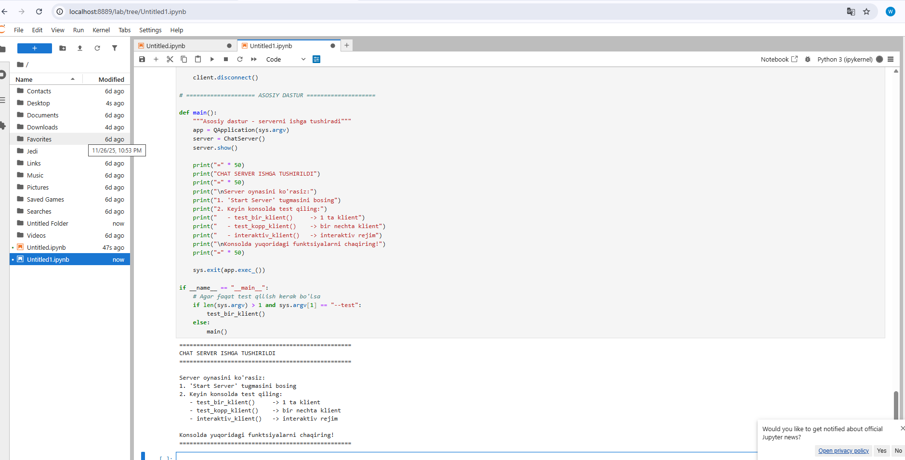

# -*- coding: utf-8 -*-
"""
Klient-Serverchi - Bitta faylda chat server va test klienti
"""

import sys
import socket
import threading
import time
from datetime import datetime
from PyQt5.QtWidgets import *
from PyQt5.QtCore import *
from PyQt5.QtGui import *
import base64

# ==================== SERVER QISMI ====================

class ChatServer(QMainWindow):
def __init__(self):
super().__init__()
self.server = None
self.running = False
self.clients = []
self.setup_ui()

def setup_ui(self):
self.setWindowTitle('Chat Server')
self.setGeometry(100, 100, 800, 600)

# Asosiy widget
main_widget = QWidget()
self.setCentralWidget(main_widget)
layout = QVBoxLayout(main_widget)

# 1. Server boshqaruvi
server_frame = QFrame()
server_frame.setFrameStyle(QFrame.StyledPanel)
server_layout = QHBoxLayout()

server_layout.addWidget(QLabel("IP:"))
self.ip_input = QLineEdit("127.0.0.1")
server_layout.addWidget(self.ip_input)

server_layout.addWidget(QLabel("Port:"))
self.port_input = QLineEdit("9999")
server_layout.addWidget(self.port_input)

self.start_btn = QPushButton("Start Server")
self.start_btn.clicked.connect(self.start_server)
self.start_btn.setStyleSheet("background-color: #4CAF50; color: white;")
server_layout.addWidget(self.start_btn)

self.stop_btn = QPushButton("Stop Server")
self.stop_btn.clicked.connect(self.stop_server)
self.stop_btn.setEnabled(False)
self.stop_btn.setStyleSheet("background-color: #f44336; color: white;")
server_layout.addWidget(self.stop_btn)

self.status_label = QLabel("TO'XTATILGAN")
self.status_label.setStyleSheet("color: red; font-weight: bold; font-size: 12px;")
server_layout.addWidget(self.status_label)

server_layout.addStretch()
server_frame.setLayout(server_layout)
layout.addWidget(server_frame)

# 2. Klientlar ro'yxati
layout.addWidget(QLabel("Ulangan Klientlar:"))
self.clients_table = QTableWidget()
self.clients_table.setColumnCount(4)
self.clients_table.setHorizontalHeaderLabels(["Ism", "IP", "Port", "Vaqt"])
self.clients_table.horizontalHeader().setStretchLastSection(True)
layout.addWidget(self.clients_table)

self.disconnect_btn = QPushButton("Tanlangan klientni uzish")
self.disconnect_btn.clicked.connect(self.disconnect_client)
self.disconnect_btn.setEnabled(False)
layout.addWidget(self.disconnect_btn)

# 3. Xabarlar logi
layout.addWidget(QLabel("Shifrlangan Xabarlar:"))
self.log_text = QTextEdit()
self.log_text.setReadOnly(True)
self.log_text.setFont(QFont("Courier New", 9))
layout.addWidget(self.log_text)

# Tugmalar
btn_frame = QFrame()
btn_layout = QHBoxLayout()

clear_btn = QPushButton("Logni tozalash")
clear_btn.clicked.connect(lambda: self.log_text.clear())
btn_layout.addWidget(clear_btn)

test_btn = QPushButton("Test xabar yuborish")
test_btn.clicked.connect(self.send_test_message)
btn_layout.addWidget(test_btn)

btn_layout.addStretch()
btn_frame.setLayout(btn_layout)
layout.addWidget(btn_frame)

# Menyu
menubar = self.menuBar()
file_menu = menubar.addMenu("Fayl")

save_action = QAction("Logni saqlash", self)
save_action.triggered.connect(self.save_log)
file_menu.addAction(save_action)

exit_action = QAction("Chiqish", self)
exit_action.triggered.connect(self.close)
file_menu.addAction(exit_action)

# Jadval tanlash
self.clients_table.itemSelectionChanged.connect(
lambda: self.disconnect_btn.setEnabled(
self.clients_table.currentRow() >= 0
)
)

def start_server(self):
ip = self.ip_input.text()
try:
port = int(self.port_input.text())
except:
QMessageBox.warning(self, "Xato", "Port noto'g'ri!")
return

try:
self.server = socket.socket(socket.AF_INET, socket.SOCK_STREAM)
self.server.setsockopt(socket.SOL_SOCKET, socket.SO_REUSEADDR, 1)
self.server.bind((ip, port))
self.server.listen(5)
self.running = True

self.status_label.setText("ISHLAYAPTI")
self.status_label.setStyleSheet("color: green; font-weight: bold; font-size: 12px;")
self.start_btn.setEnabled(False)
self.stop_btn.setEnabled(True)

self.add_log(f"[{datetime.now().strftime('%H:%M:%S')}] Server {ip}:{port} da ishga tushdi")

# Klientlarni qabul qilish
accept_thread = threading.Thread(target=self.accept_clients, daemon=True)
accept_thread.start()

except Exception as e:
QMessageBox.critical(self, "Xato", f"Server ishga tushmadi: {str(e)}")

def stop_server(self):
self.running = False

# Barcha klientlarni uzish
for client in self.clients:
try:
client['socket'].close()
except:
pass
self.clients.clear()
self.update_clients_table()

if self.server:
try:
self.server.close()
except:
pass

self.status_label.setText("TO'XTATILGAN")
self.status_label.setStyleSheet("color: red; font-weight: bold; font-size: 12px;")
self.start_btn.setEnabled(True)
self.stop_btn.setEnabled(False)

self.add_log(f"[{datetime.now().strftime('%H:%M:%S')}] Server to'xtatildi")

def accept_clients(self):
while self.running:
try:
client_socket, addr = self.server.accept()

# Birinchi xabar - foydalanuvchi ismi
try:
nickname = client_socket.recv(1024).decode('utf-8').strip()
if not nickname:
nickname = f"User_{addr[1]}"
except:
nickname = f"User_{addr[1]}"

client_info = {
'socket': client_socket,
'nickname': nickname,
'ip': addr[0],
'port': addr[1],
'time': datetime.now().strftime("%H:%M:%S")
}

self.clients.append(client_info)
self.update_clients_table()

self.add_log(f"[{datetime.now().strftime('%H:%M:%S')}] {nickname} ulandi ({addr[0]})")

# Klientni qayta ishlash
client_thread = threading.Thread(
target=self.handle_client,
args=(client_info,),
daemon=True
)
client_thread.start()

except Exception as e:
if self.running:
print(f"Qabul qilish xatosi: {e}")
break

def handle_client(self, client_info):
sock = client_info['socket']

while self.running:
try:
data = sock.recv(4096)
if not data:
break

# Xabarni shifrlash (base64)
encoded_msg = base64.b64encode(data).decode('utf-8')

# Logga yozish
timestamp = datetime.now().strftime("%H:%M:%S")
log_entry = f"[{timestamp}] [{client_info['nickname']}/{client_info['ip']}]: {encoded_msg}"

self.add_log(log_entry)

# Boshqa klientlarga yuborish (ixtiyoriy)
for client in self.clients:
if client['socket'] != sock:
try:
client['socket'].send(data)
except:
pass

except:
break

# Klient uzilgan
self.client_disconnected(client_info)

def client_disconnected(self, client_info):
if client_info in self.clients:
self.clients.remove(client_info)
self.update_clients_table()

try:
client_info['socket'].close()
except:
pass

self.add_log(f"[{datetime.now().strftime('%H:%M:%S')}] {client_info['nickname']} uzildi")

def disconnect_client(self):
row = self.clients_table.currentRow()
if 0 <= row < len(self.clients):
client = self.clients[row]
self.client_disconnected(client)

def update_clients_table(self):
self.clients_table.setRowCount(len(self.clients))

for i, client in enumerate(self.clients):
self.clients_table.setItem(i, 0, QTableWidgetItem(client['nickname']))
self.clients_table.setItem(i, 1, QTableWidgetItem(client['ip']))
self.clients_table.setItem(i, 2, QTableWidgetItem(str(client['port'])))
self.clients_table.setItem(i, 3, QTableWidgetItem(client['time']))

def add_log(self, message):
self.log_text.append(message)
# Avtomatik pastga scroll
scrollbar = self.log_text.verticalScrollBar()
scrollbar.setValue(scrollbar.maximum())

def send_test_message(self):
"""Test xabar - server o'ziga yuboradi"""
if self.clients:
test_msg = f"[SERVER TEST] {datetime.now().strftime('%H:%M:%S')}"
encoded = base64.b64encode(test_msg.encode()).decode('utf-8')
self.add_log(f"[{datetime.now().strftime('%H:%M:%S')}] [SERVER/TEST]: {encoded}")
else:
QMessageBox.information(self, "Info", "Hozircha klient yo'q")

def save_log(self):
filename, _ = QFileDialog.getSaveFileName(
self, "Logni saqlash", "chat_log.txt", "Text Files (*.txt)"
)
if filename:
try:
with open(filename, 'w', encoding='utf-8') as f:
f.write(self.log_text.toPlainText())
self.add_log(f"[{datetime.now().strftime('%H:%M:%S')}] Log saqlandi: {filename}")
except Exception as e:
QMessageBox.critical(self, "Xato", f"Saqlab bo'lmadi: {str(e)}")

def closeEvent(self, event):
self.stop_server()
event.accept()

# ==================== KLIENT QISMI ====================

class ChatClient:
"""Oddiy chat klienti (konsolda ishlaydi)"""

def __init__(self, name="User", server_ip="127.0.0.1", server_port=9999):
self.name = name
self.server_ip = server_ip
self.server_port = server_port
self.socket = None
self.connected = False

def connect(self):
"""Serverni ulanish"""
try:
self.socket = socket.socket(socket.AF_INET, socket.SOCK_STREAM)
self.socket.connect((self.server_ip, self.server_port))

# Ismni yuborish
self.socket.send(self.name.encode('utf-8'))
self.connected = True

print(f"✅ {self.name} serverga ulandi")
return True

except Exception as e:
print(f"❌ Ulanish xatosi: {e}")
return False

def send(self, message):
"""Xabar yuborish"""
if not self.connected:
print("Serverga ulanmagan!")
return False

try:
self.socket.send(message.encode('utf-8'))
print(f"📤 {self.name}: {message}")
return True
except Exception as e:
print(f"❌ Yuborish xatosi: {e}")
return False

def receive(self):
"""Xabarlarni qabul qilish (threadda)"""
while self.connected:
try:
data = self.socket.recv(4096)
if not data:
break
print(f"📥 Qabul qilindi: {len(data)} bayt")
except:
break

def start_receiving(self):
"""Qabul qilishni boshlash"""
if self.connected:
thread = threading.Thread(target=self.receive, daemon=True)
thread.start()

def disconnect(self):
"""Uzish"""
if self.socket:
try:
self.socket.close()
except:
pass
self.connected = False
print(f"🔌 {self.name} uzildi")

# ==================== TEST FUNKTSIYALARI ====================

def test_bir_klient():
"""1 ta klient bilan test"""
print("\n=== 1 ta klient testi ===")

client = ChatClient("Ali")

if client.connect():
client.start_receiving()

# Bir nechta xabar yuborish
messages = [
"Salom hammaga!",
"Bu test xabar",
"Chat ishlayaptimi?",
"Yaxshi ishlayapti!"
]

for msg in messages:
client.send(msg)
time.sleep(1)

time.sleep(2)
client.disconnect()

print("Test tugadi!")

def test_kopp_klient():
"""Bir nechta klient bilan test"""
print("\n=== Bir nechta klient testi ===")

clients = []
names = ["Ali", "Vali", "Hasan", "Husan"]

# Barchasini ulash
for name in names:
client = ChatClient(name)
if client.connect():
clients.append(client)
time.sleep(0.3)

if clients:
# Har biriga xabar yuborish
for i, client in enumerate(clients):
client.send(f"Salom, men {client.name}!")
time.sleep(0.5)

time.sleep(2)

# Uzish
for client in clients:
client.disconnect()

print("Test tugadi!")

def interaktiv_klient():
"""Interaktiv klient (konsolda)"""
print("\n=== Interaktiv Klient ===")

name = input("Ismingizni kiriting: ").strip() or "Foydalanuvchi"
client = ChatClient(name)

if not client.connect():
return

client.start_receiving()

print(f"\nXabarlaringizni yuboring ('chiq' yozib chiqing):")
print("-" * 40)

while True:
message = input(f"{name}> ").strip()

if message.lower() in ['chiq', 'exit', 'quit']:
break

if message:
client.send(message)

client.disconnect()

# ==================== ASOSIY DASTUR ====================

def main():
"""Asosiy dastur - serverni ishga tushiradi"""
app = QApplication(sys.argv)
server = ChatServer()
server.show()

print("=" * 50)
print("CHAT SERVER ISHGA TUSHIRILDI")
print("=" * 50)
print("\nServer oynasini ko'rasiz:")
print("1. 'Start Server' tugmasini bosing")
print("2. Keyin konsolda test qiling:")
print(" - test_bir_klient() -> 1 ta klient")
print(" - test_kopp_klient() -> bir nechta klient")
print(" - interaktiv_klient() -> interaktiv rejim")
print("\nKonsolda yuqoridagi funktsiyalarni chaqiring!")
print("=" * 50)

sys.exit(app.exec_())

if __name__ == "__main__":
# Agar faqat test qilish kerak bo'lsa
if len(sys.argv) > 1 and sys.argv[1] == "--test":
test_bir_klient()
else:
main()

